Publications
 | 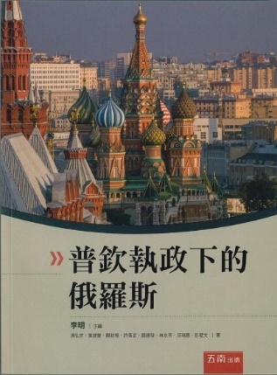
Book Title: 金磚國家俄羅斯及歐亞地區研究  (The BRICS Russia and Europe-Asia Studies)  Publication Date: January, 2012  Language: Chinese  Publisher: Wu-nan publisher, Taipei | Book Title :普欽執政下的俄羅斯  (Russia under Vladimir Putin)  Publication Date: November, 2015  Language: Chinese  Publisher: Wu-nan publisher, Taipei
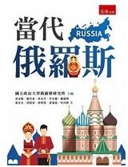 | 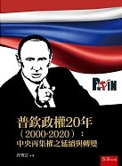
Book Title: 當代俄羅斯  (Contemporary Russia)  Publication Date: December, 2016  Language: Chinese  Publisher: Wu-nan publisher, Taipei | Book Title : 普欽政權20年（2000-2020）：中央再集權之延續與轉變 (Twenty years of the Putin Regime (2000-2020): Continuation and Transformation of Centralization)  Publication Date: February, 2023  Language: Chinese  Publisher: Wu-nan publisher, Taipei

